**Part 1**

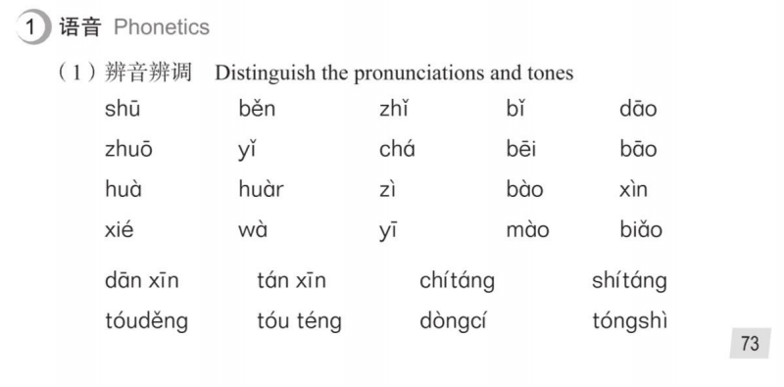

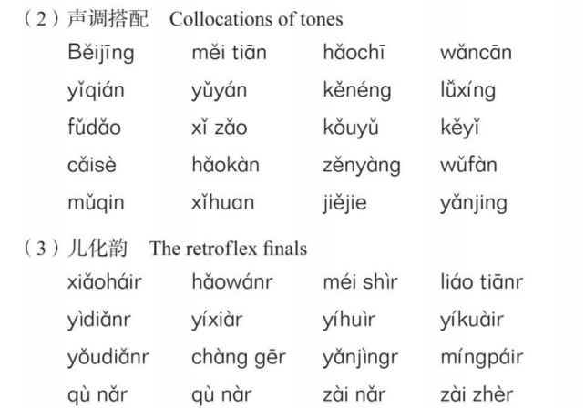

**read and retell ,then record this part as a document and sent it to me**

**Part 2**

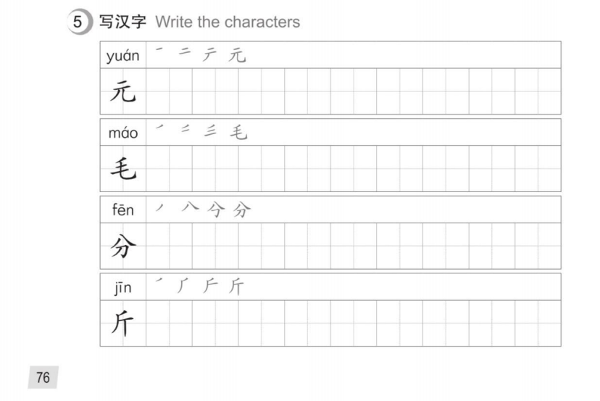

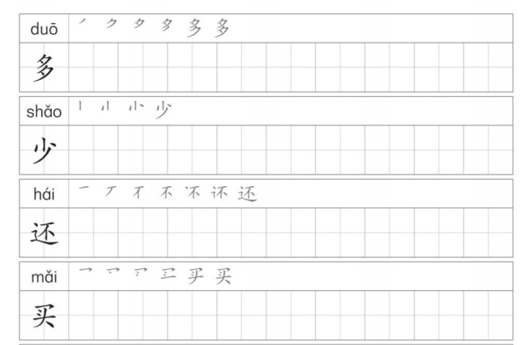

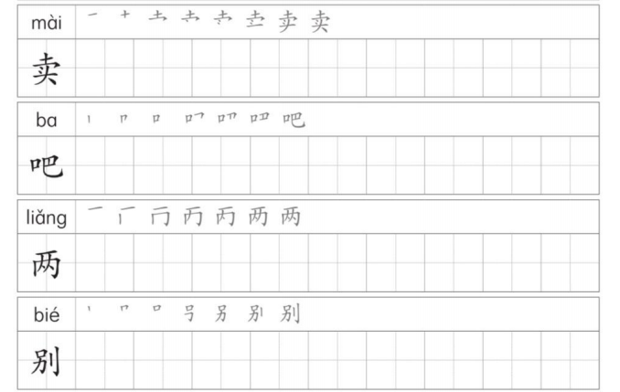

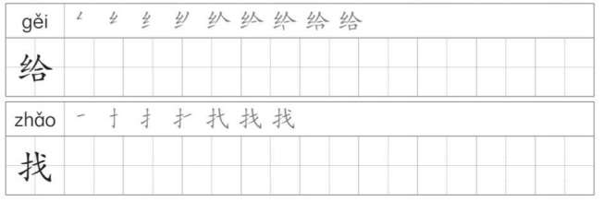

**this part needs to be handwritten and photographed**

**With each Chinese Character 10 times**

1. **Deadline : 8:00 am on November 9, 2021, Beijing time**

**Overdue homework will be marked as 0 points.**

1. **Email address :736284586@qq.com**

**Please submit the assignment to this email address**

1. **Email subject : Name + Homework4**

**Emails not marked as required shall be deemed not submitted**